**AMERICAN INTERNATIONAL**

**UNIVERSITY-BANGLADESH**

**Faculty of Science and Technology**

# Project Report

Course: Computer graphics

Section: F

# Project Topic: Village View

|  |  |
| --- | --- |
| **Name** | **ID** |
| **Mahima Farah Moon** | **20-42352-1** |

**Submitted to:**

**Dr. Md. Taimur Ahad**

Assistant Professor

Faculty of Science and Technology

Assistant Professor

|  |  |
| --- | --- |
| **Content** | Page no |
| Introduction | 3 |
| Aim of the project | 3 |
| Significant of the project | 3 |
| Project Details | 3 |
| Object Required | 3 |
| Object Behavior | 3 |
| Scene | 4-5 |
| Conclusion | 5 |

**Introduction:**

In this project we are able to see different scenario of a village. Such as day or night view or rainy time scenario. We used Open GL to create different 2D object scenario. For programming we used Code Block (IDE)

**Aim of the project:**

To watch the scenario of a Light House which is at a village. Our project will show the Day scenery, Night scenery and the Rain scenery of the village with Light House.

**Significant of the project:**

This project can be used as a role model for a village in future. Other than that, we can enjoy different scene of a village from this project.

Also, this project will help us to create more realistic view in future projects. It also helped us to learn about teamwork.

**Project details:**

In our project, we have three sceneries. Day scene, Night scene and Rain scene. Here, the light house will appear on the day scene. We need to run our code and then the Day scene will appear first. After that, if we press “N” in our keyboard then the Night scene will appear. If we press “R” then, the Rain scene will appear. The light house will not scene in the Night scene and Rain scene. We have used code blocks software to make our project. Here we used the “Glut Project” application.

**Object required:**

We have some houses, trees, hills, clouds, a river, a light house, Sun, Moon, Star, and some boats in our scenario.

**Object Behavior:**

Every object has significant role in this project. The boats will move from one side to another side of the river. The river will flow. The light house will appear in the day scene. There’ll be sun in the day scene. In the rainy scenery, we will see rain fall in the village. We’ll see the moon and some stars in the sky on our night scene.

**Scene:**

**Day Scene:**

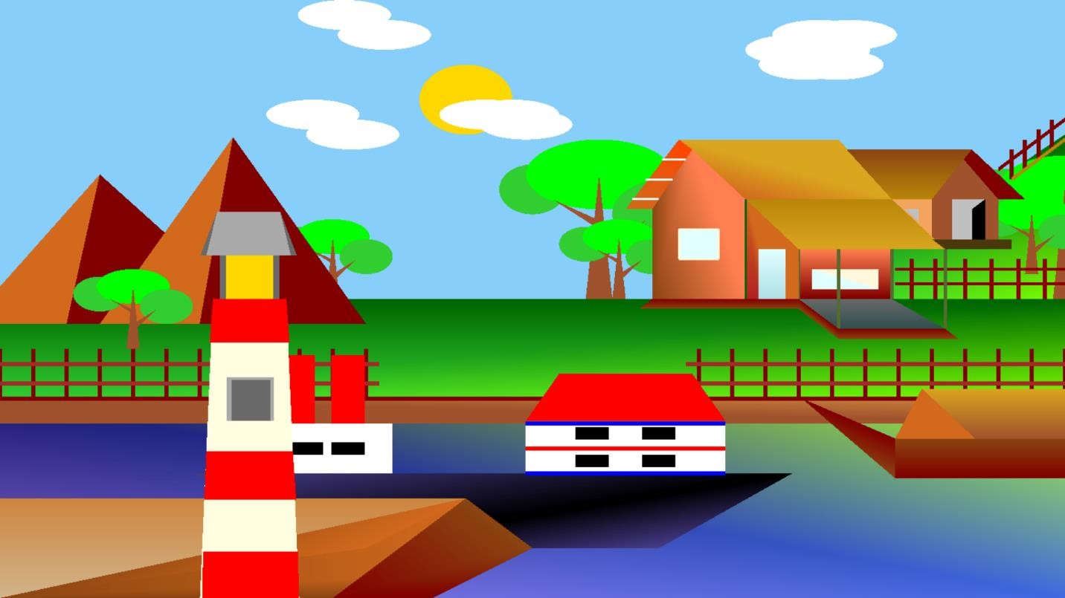

**Night Scene:**

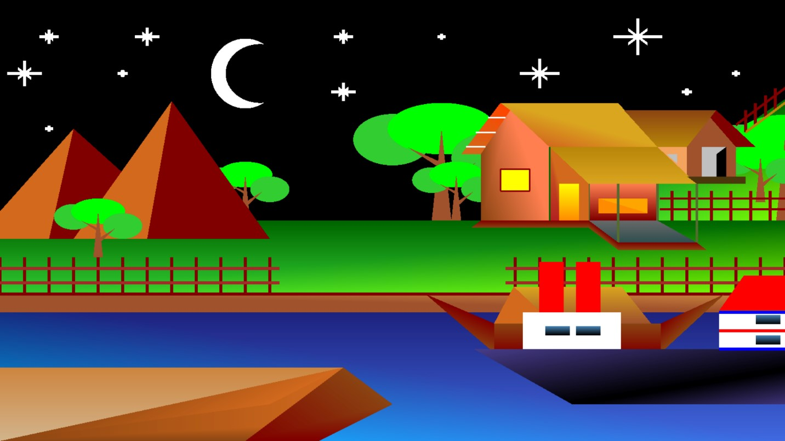

**Rain Scene:**

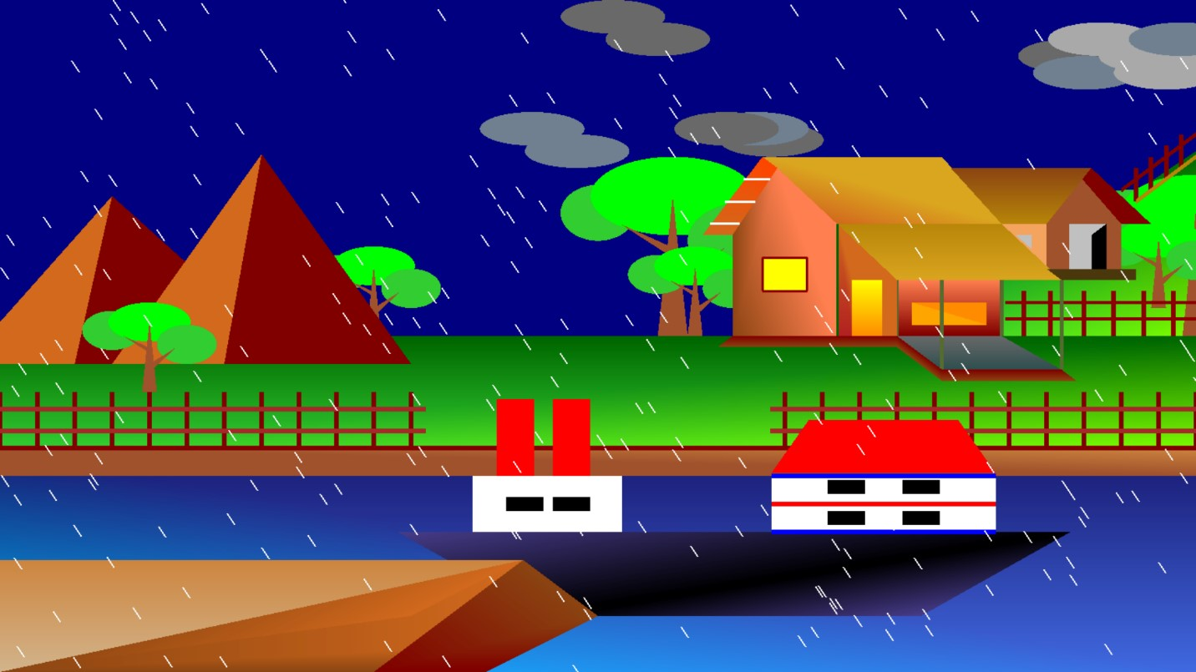

**Conclusion:** In our project, the code was done properly. We compiled our code with code blocks software. The animations were beautiful, so our project scenario was beautiful. This project can help other peoples to make a good animation of a village. Engineers can think about the concept of the light house in a village. Usually, we don’t see any light house at villages. But in this project, we have made an idea about the light house at a village.